Spearman rank correlation: GBPUSD and USDJPY
Method 02 / daily log returns / Alpari D1 full available history

Study setup
Logical pair: GBPUSD , USDJPY
Broker symbols: GBPUSD_i , USDJPY_i
Snapshot: 2026-11-03_majors_alpari_D1
Timeframe: D1
Matched return window: 1999-01-05 to 2026-11-02 (UTC bar dates)
Matched return count n: 7200
Dropped unfinished last bar dated 2026-11-03 UTC after a tick-volume check against the prior complete day.
Complete matched rows (CSV): GBPUSD-USDJPY_Spearman_D1.csv
Complete matched rows (HTML table): GBPUSD-USDJPY_Spearman_D1_data.html

Method carried forward
Spearman rho is Pearson correlation on the ranks of matched daily log returns of close, ln(close_t / close_t-1), in the broker quote direction. Ties use average ranks. Quotes are not inverted. rho is symmetric under swap of the two symbols. rho = 0 means no consistent rank-order link in this sample; it does not mean no link of any kind. The score is not a cause, not a lead, and not a trading signal. Daily rows are not independent draws, so the two-sided p-value and approximate Fisher interval are reported and treated as secondary to rho. Same-sample Pearson r is shown only as a side check; a large rho minus r gap can flag outliers or a non-straight link.

Results
Spearman rho: -0.273964
Two-sided p-value: 3.83282e-124
Approximate 95% Fisher interval: [-0.295195, -0.252463]
Same-sample Pearson r: -0.198556
rho minus r: -0.075409

Conclusion
Over 7200 matched daily log-return rows for GBPUSD and USDJPY (broker quote directions unchanged), Spearman rho is -0.2740 (negative, weak rank-order association in this sample). Approximate 95% Fisher interval: [-0.2952, -0.2525]. Same-sample Pearson r is -0.1986 (rho minus r = -0.0754). Two-sided p under the usual independent-ranks model is 3.833e-124; that model does not match linked daily FX returns, so treat p as secondary. This does not establish cause, lead-lag, or a lasting trading rule.

Charts
Daily closes

Daily log returns
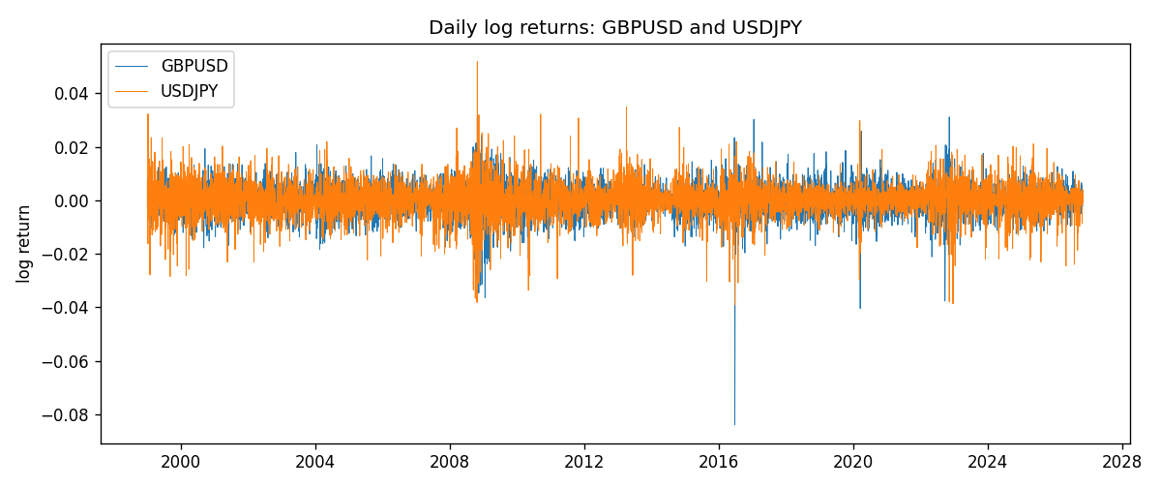
Log-return scatter
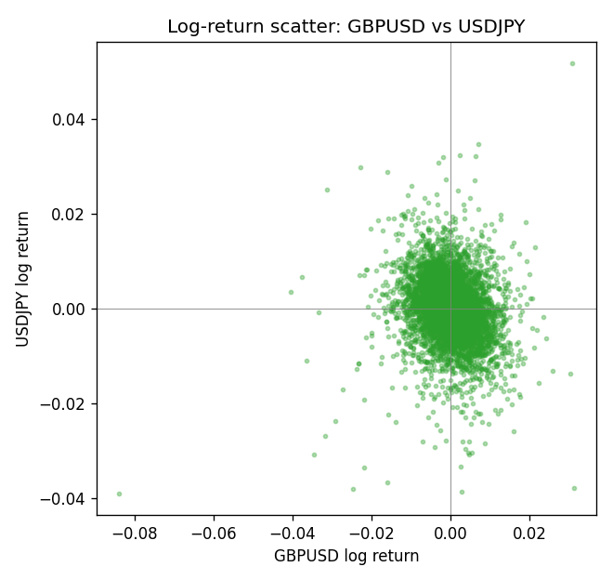
Rank-rank scatter
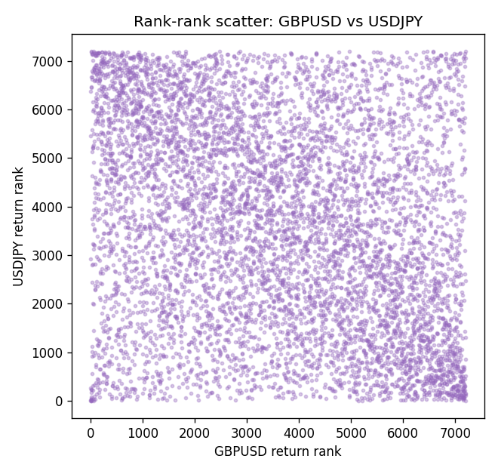

Data report
Every matched row that entered Spearman rho is stored in the sibling CSV named GBPUSD-USDJPY_Spearman_D1.csv. That file is the complete data archive for redrawing charts. Embedding all rows as a Word table is impractical at this length; the Word file holds the column list, column summaries, and the first and last 15 matched rows.
Columns: time, GBPUSD_open, USDJPY_open, GBPUSD_high, USDJPY_high, GBPUSD_low, USDJPY_low, GBPUSD_close, USDJPY_close, GBPUSD_tick_volume, USDJPY_tick_volume, GBPUSD_spread, USDJPY_spread, GBPUSD_real_volume, USDJPY_real_volume, GBPUSD_log_return, USDJPY_log_return
Column summaries (matched calculation rows)
column | count | mean | std | min | 25% | 50% | 75% | max
GBPUSD_open | 7200 | 1.5159933 | 0.21821503 | 1.06854 | 1.3249725 | 1.51133 | 1.63163 | 2.1066
USDJPY_open | 7200 | 113.81122 | 19.205564 | 75.693 | 104.42925 | 110.991 | 120.69125 | 163.824
GBPUSD_high | 7200 | 1.5222906 | 0.21878569 | 1.08366 | 1.329785 | 1.518035 | 1.638315 | 2.1161
USDJPY_high | 7200 | 114.30876 | 19.267108 | 76.001 | 104.8815 | 111.4435 | 121.26 | 163.978
GBPUSD_low | 7200 | 1.5096683 | 0.2174426 | 1.03518 | 1.319445 | 1.50319 | 1.6243 | 2.0983
USDJPY_low | 7200 | 113.28793 | 19.133561 | 75.402 | 103.89 | 110.5305 | 120.17 | 163.628
GBPUSD_close | 7200 | 1.5160611 | 0.21817876 | 1.06879 | 1.3250775 | 1.511235 | 1.63193 | 2.1065
USDJPY_close | 7200 | 113.82409 | 19.220954 | 75.811 | 104.42 | 111.028 | 120.6855 | 163.851
GBPUSD_tick_volume | 7200 | 94838.03 | 153554.65 | 62 | 10001.75 | 52905.5 | 91812.25 | 1273370
USDJPY_tick_volume | 7200 | 106136.9 | 179308.31 | 149 | 9925 | 53095 | 92761 | 1803508
GBPUSD_spread | 7200 | 26.967917 | 19.192953 | 0 | 11 | 20 | 50 | 50
USDJPY_spread | 7200 | 20.325556 | 17.633971 | 0 | 6 | 11 | 30 | 50
GBPUSD_real_volume | 7200 | 3.5565837e+09 | 8.4444068e+10 | 0 | 0 | 0 | 0 | 2.4038164e+12
USDJPY_real_volume | 7200 | 3.470121e+10 | 1.6077679e+11 | 0 | 0 | 0 | 0 | 3.8834203e+12
GBPUSD_log_return | 7200 | -2.396e-05 | 0.00564572 | -0.08388241 | -0.0031301 | 3.232e-05 | 0.00317911 | 0.03112653
USDJPY_log_return | 7200 | 4.769e-05 | 0.00620489 | -0.03908203 | -0.00320192 | 0.00011421 | 0.00340709 | 0.05184024
First 15 matched rows (selected columns)
time | GBPUSD_close | USDJPY_close | GBPUSD_log_return | USDJPY_log_return | GBPUSD_tick_volume | USDJPY_tick_volume
1999-01-05 | 1.6547 | 111.92 | -0.0028966287 | -0.00017868311 | 4645 | 6367
1999-01-06 | 1.6537 | 112.77 | -0.00060452184 | 0.0075660159 | 4729 | 6225
1999-01-07 | 1.6502 | 111.33 | -0.002118709 | -0.012851583 | 4858 | 6671
1999-01-08 | 1.6405 | 110.8 | -0.0058954193 | -0.0047719894 | 5354 | 10700
1999-01-11 | 1.6312 | 109.02 | -0.0056851331 | -0.016195423 | 4080 | 9168
1999-01-12 | 1.6349 | 112.6 | 0.0022657001 | 0.032310364 | 5001 | 10131
1999-01-13 | 1.6499 | 113.52 | 0.0091330396 | 0.0081373171 | 5730 | 7265
1999-01-14 | 1.6531 | 113.52 | 0.0019376331 | 0 | 4902 | 6335
1999-01-15 | 1.6502 | 114.15 | -0.0017558204 | 0.0055343401 | 6383 | 5479
1999-01-18 | 1.6522 | 114.16 | 0.0012112405 | 8.7600193e-05 | 4357 | 5482
1999-01-19 | 1.6553 | 113.52 | 0.0018745281 | -0.0056219403 | 4655 | 5702
1999-01-20 | 1.6472 | 112.91 | -0.0049053846 | -0.0053879917 | 4502 | 5919
1999-01-21 | 1.6524 | 113.87 | 0.0031518998 | 0.0084664056 | 4609 | 6251
1999-01-22 | 1.6565 | 114.56 | 0.0024781662 | 0.0060412564 | 4230 | 5453
1999-01-25 | 1.6585 | 113.72 | 0.0012066366 | -0.0073594164 | 3069 | 4696
Last 15 matched rows (selected columns)
time | GBPUSD_close | USDJPY_close | GBPUSD_log_return | USDJPY_log_return | GBPUSD_tick_volume | USDJPY_tick_volume
2026-10-13 | 1.32534 | 158.305 | 0.0036434319 | -0.0018932826 | 53930 | 81731
2026-10-14 | 1.31884 | 158.317 | -0.0049164679 | 7.5800166e-05 | 64640 | 95596
2026-10-15 | 1.32757 | 158.024 | 0.0065976411 | -0.0018524319 | 80461 | 115120
2026-10-16 | 1.33257 | 157.964 | 0.0037592051 | -0.00037976126 | 65988 | 86475
2026-10-19 | 1.33024 | 158.517 | -0.0017500314 | 0.0034946841 | 56543 | 70872
2026-10-20 | 1.3377 | 158.16 | 0.0055923442 | -0.0022546642 | 58955 | 82689
2026-10-21 | 1.33937 | 158.108 | 0.0012476328 | -0.00032883504 | 55613 | 67431
2026-10-22 | 1.33967 | 156.755 | 0.00022396082 | -0.0085942669 | 64255 | 100312
2026-10-23 | 1.33684 | 156.81 | -0.0021146949 | 0.00035080446 | 58068 | 103374
2026-10-26 | 1.33359 | 157.458 | -0.0024340661 | 0.0041238746 | 56434 | 87120
2026-10-27 | 1.33044 | 157.894 | -0.0023648393 | 0.0027651658 | 54846 | 72962
2026-10-28 | 1.33254 | 157.743 | 0.0015771808 | -0.00095679538 | 61264 | 72076
2026-10-29 | 1.33733 | 157.683 | 0.0035881935 | -0.00038043789 | 71194 | 88229
2026-10-30 | 1.33913 | 157.516 | 0.0013450605 | -0.0010596481 | 70446 | 106706
2026-11-02 | 1.3406 | 157.933 | 0.0010971256 | 0.0026438521 | 60471 | 80702

